Web Development Lesson Plan

|  |  |  |
| --- | --- | --- |
| Session: 2 | Topic: Setting up Django | Day: 2 |

|  |
| --- |
| Lesson Objective:  This exercise will...   * Setup Django for web development   The purpose of this lesson is also that   * Students can practice working with the command line. |
| Materials Needed:   * Internet access * Web browser |
| Agenda:   1. Django versions (10 minutes) 2. Download Django (20 minutes) |
| Procedure:  Student can do this fully independently by reading the instructions, or someone can read the instructions to make sure the task is understood before doing the activity. The reflection part can be done with guided instructions, or in pairs with other students if available to compare notes. |
| Assessment/Check for learning:   * Students can identify concrete things that they missed in their observation (note that this is not a bad thing, the purpose of this lesson is to realize that intentionally looking for information comes with the ‘penalty’ of reduced attention to other things. |

What if:

* Student has already shown proficiency in that skill?
  + Pick a movie or episode in which a lot of things are happening, so that there are more things for the student to keep track of.
* Student is having a hard day and needs special accommodations?
  + Pick a movie or episode in which only a few things are happening, so that there are less things for the student to keep track of.
  + Instead of writing, the student can also take spoken notes with an audio recorder. This will be a bit trickier in the second part but audio in the movie can be supported with subtitles.

NOTES:

* Duration is approximately 50 minutes; can be adjusted by shortening the duration of the film clip. Less than 10 minutes is not recommended unless really necessary.

**Instructions**

**Django versions (10 minutes)**

Step 1:

In this lesson we will download Django. Before we do that we need to cover the various versions of Django. Read the following article to learn why it is important to have the right Django version:

<https://www.mattlayman.com/blog/2021/which-django-version/>

**Download Django (20 minutes)**

Step 1:

Now we will download Django on your computer. You will need to download Django each time you create a new virtual environment. After we complete the setup process you will be able to access Django inside your virtual environment.

Step 2:

To download the official and most up-to-date version of Django visit this page:

<https://www.djangoproject.com/download/>

Step 3:

Now we will copy the code that is listed in **Option 1**. It may be possible that you see a different version. The code you need to copy in this case is:

pip install Django==3.2.6

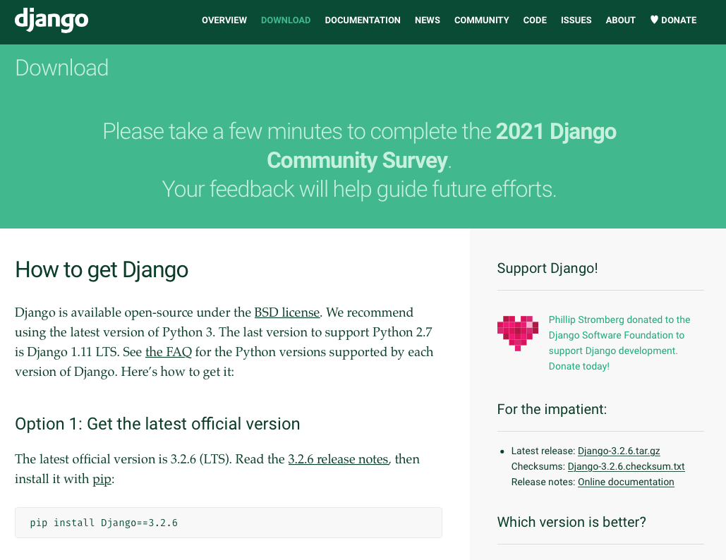

Step 4:

Create a folder called “Lesson9”.

Step 5:

CD into “Lesson9” folder.

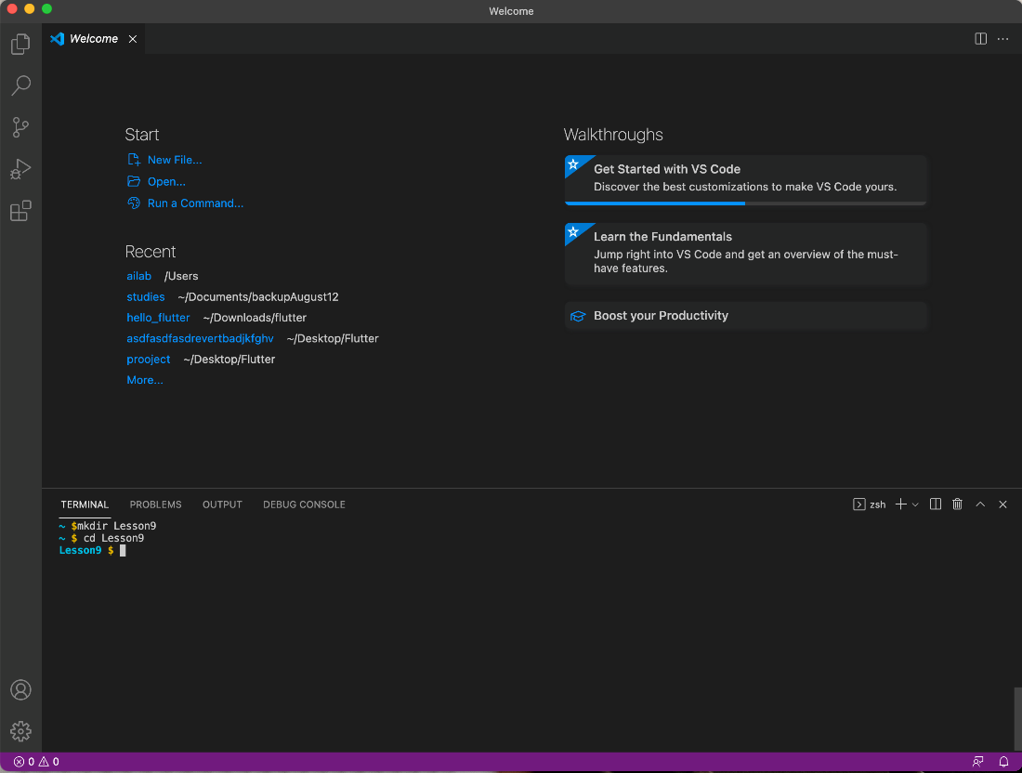

Step 6:

Now create a new virtual environment by running the following command:

virtualenv env –p python3

Step 7:

Next activate the virtual environment with the following command:

source env/bin/activate

Step 8:

You should now see the “env” tag at the front of your command line:  
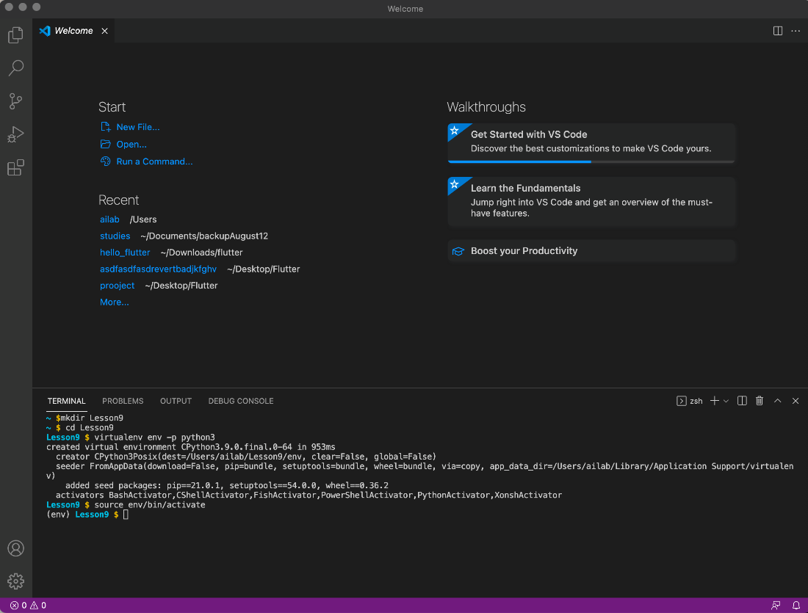

Step 9:

Next, we will paste the command from the Django website:

pip install Django==3.2.6

Step 10:

After pasting the command, press enter to run the command. You should see the following:

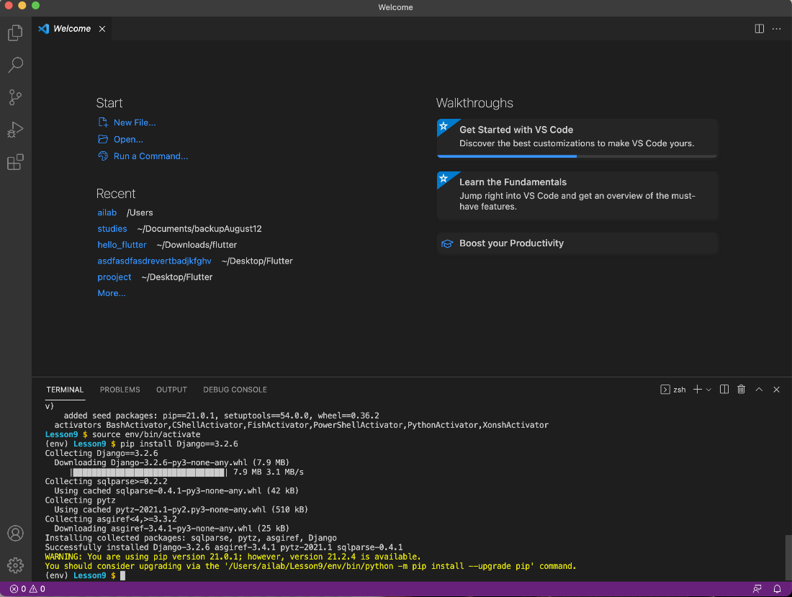

Step 11:

The installation was successful. You can ignore the yellow text.

Step 12:

You have now successfully installed Django inside your virtual environment. You will be able to access Django from this folder. Follow the steps to download Django for another virtual environment.

In the following lesson you create you first Django project.